RAG ChatBot Testing document



PDF Data
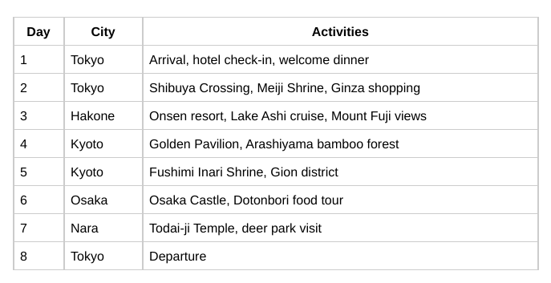
The response satisfactorily matched with above table present in PDF.

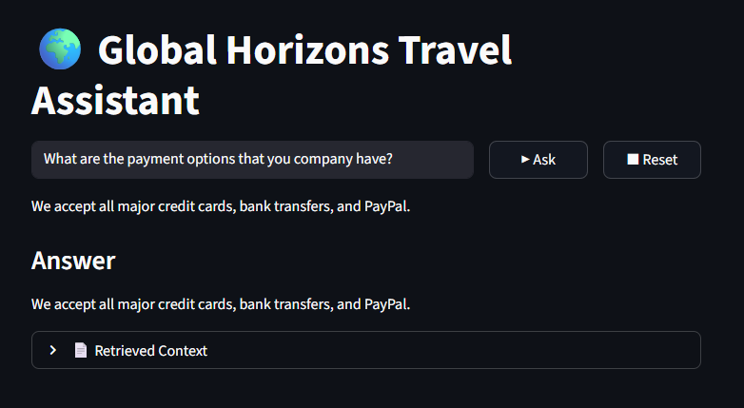

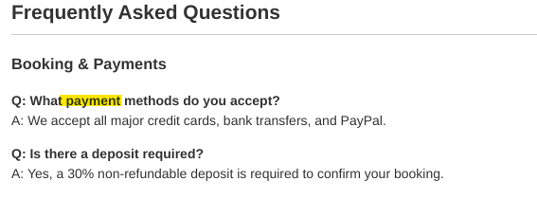

It successfully able to get the correct line related to payment method.

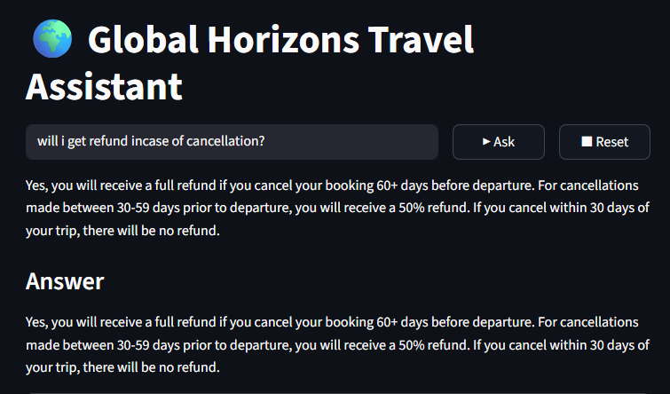

PDF Data

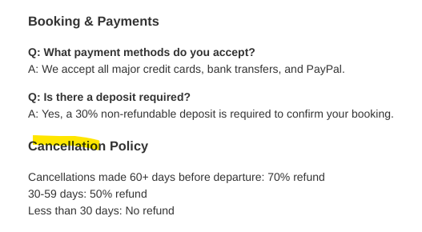
Here the model told the correct response for 30-59 days & 30 days but failed to answered correctly for 60+ days
Chunks Retrieved
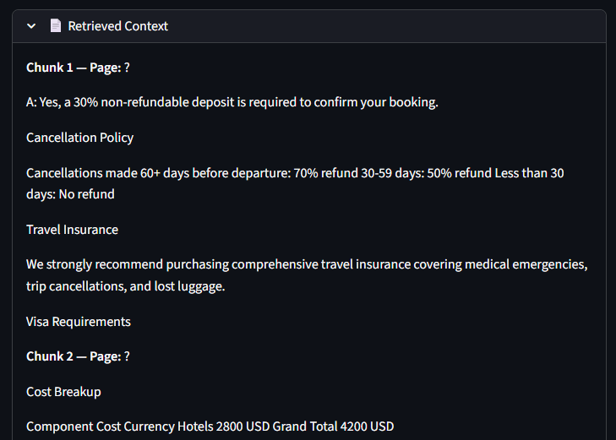

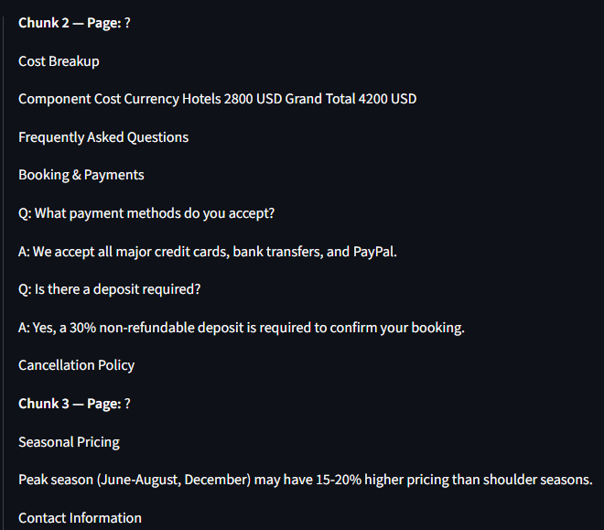



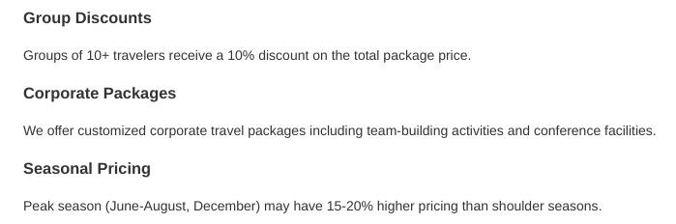
Analysis:
It told the correct response but didn’t tell about percentage of response.

